Final Report Project A

Abstract:

This project focuses on solving a two-dimensional Helmholtz equation given specific boundary conditions (both Neumann and Dirichlet) and rectangle domain. In order to complete with the requirements of the problem statement, it was crucial to create a MATLAB code that would be able to simulate all the conditions needed to approximate the solution numerically. The simulation takes into account two different adaptive iterative methods for linear systems; the Gauss-seidel method and the successive over-relation method (SOR). Both methods follow a similar derivation, especially since the SOR method is a more generalized than the Gauss-seidel method. However, each differ in some respects such as the arithmetic derivation, and also the time each method takes to convergence to the solution. Such aspects serve as a way to analyze the properties of each method’s results through the use of visualizations and graphs for a better comprehension of the code.

The main body of this report is divided into several steps taken to achieve the project’s plan development. The mathematical statement of the problem section provides with information about the its scope and problem definition, the mathematical derivation of the discretized equations used for the boundary value (Neumann) and the finite difference approximation (central) of the inner grid points, and a succinct description of the iteration methods used both the Gauss-seidel and SOR. Another part of the body introduces the technical specifications of the computer where the code was executed, to offer some insight of the computer’s performance, memory information, and processing power.

After running and debugging the script that solves the project assignment, the results are presented in the shape of graphs and other visualizations. The code written has comments to allow a better comprehension of the code and the output allowed to make a mesh convergence and independence study. The results will be analyzed for both methods and compared to each other in terms of the number of iterations taken to convergence, the difference in approximated values, error analysis and the convergence solution.

Mathematical statement of problem:

Given a fixed frequency and by applying the Fourier transformation in time, the Maxwell equations are reduced to a set of stationary equations in the frequency domain, which in turn can be compacted into a single differential equation of the second order known as the Helmholtz equation. This type of applications is usually modeled in domains whose geometries are very complex, which makes it unlikely to obtain a closed or analytical expression for the solution of said equation, so its numerical approximation is fundamental. The Helmholtz equation is a time-independent partial differential equation that conforms the category of elliptic PDEs, and it aids in the study of physical problems in both space and time. Figure 1 shows the particular Helmholtz equation for the specified boundary conditions, domain conditions, and given constant values such as the wavenumber (Λ) and the domain values ax, ay, bx, and by.

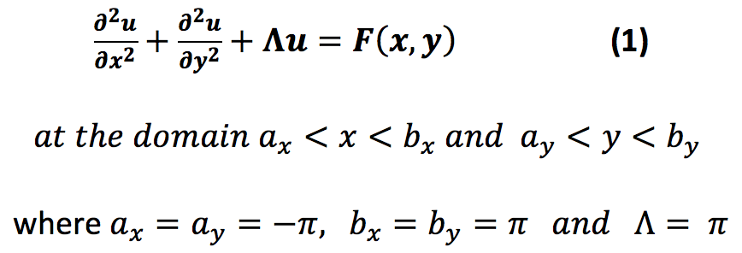

Figure 1- Helmholtz Equation with specified conditions for chosen assignment

Equation 1 is a generalized form of the Laplace’s equation (also elliptic), which is derived by setting the vector function F=0 and Λ=0. The Laplace’s case will also be simulated as the final part of the assignment and results will be presented in the latter part of the report. It is also important to note that the case where F=0 and Λ<0, the equation becomes the spatial part of the parabolic diffusion equation, which is significant for the understanding of the wave propagation property of the equation in matter.

The stated problem requires boundary conditions in order to be solvable. The boundary conditions specified in the problem statement are particular to a rectangle domain and are different for every side of the proposed rectangle grid of n by m points, as shown in Figure 2.

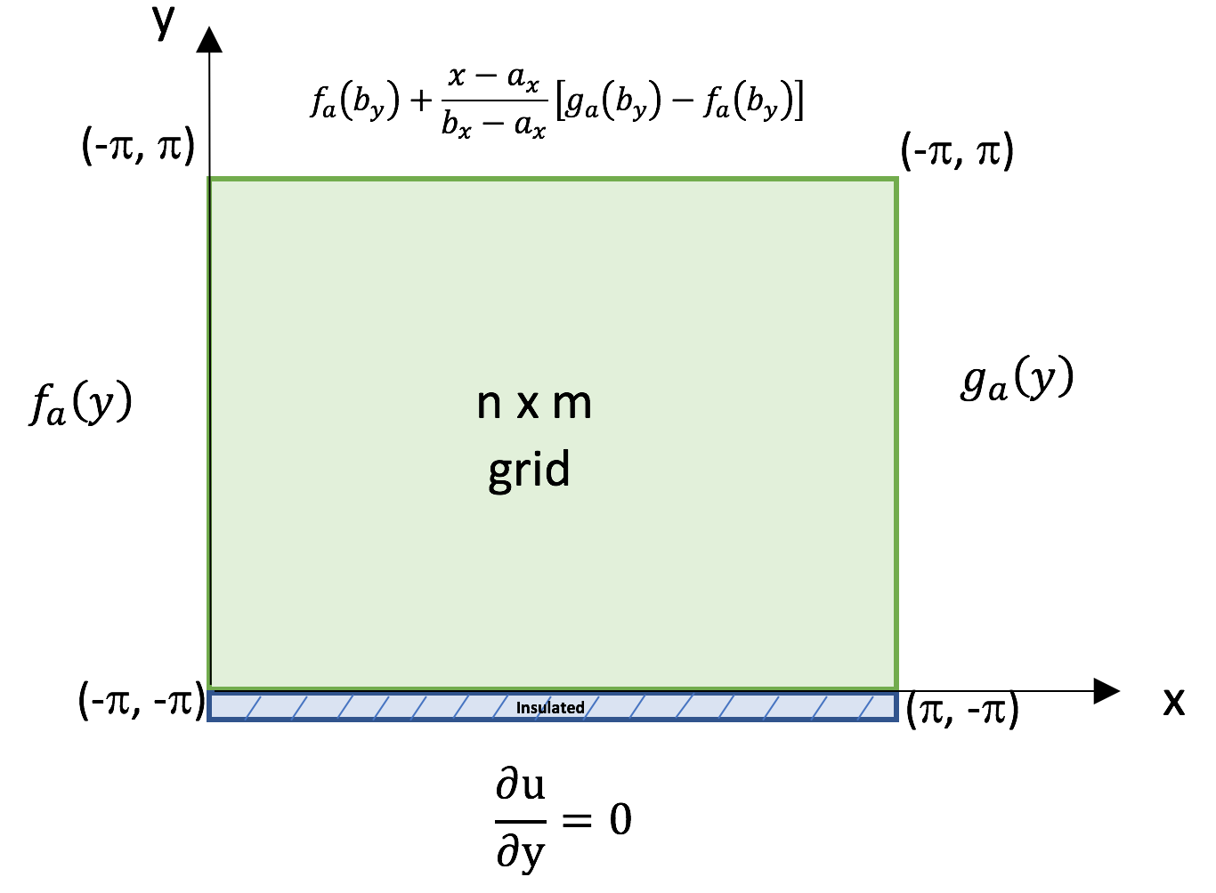

Figure 2- Representation of rectangle grid sample with boundary conditions

The values for each boundary are representative of each side of the rectangle given by different functions that ultimately affect the behavior of the boundary. The upper, left and right sides of the rectangle each represent a different function but are all Dirichlet conditions because the boundary value is known. Because they are all functions, however, the values along each boundary differs according to the x and/or y-position of the nodes within the sides of domain. This type of boundary condition is easy to apply because the solution of the boundary condition is fixed throughout the edge. The boundary on the bottom edge of the rectangle is imposed as a partial derivative, meaning that the solution to the boundary value is implied and needs to be derived. If we were talking about temperature being the u, the Neumann condition would represent the flux of heat through the edge. Because the partial derivative equation is homogenous, it is equivalent to the boundary being insulated. Figure 3 shows the given boundary functions as well as the governing equation functions in more detail.

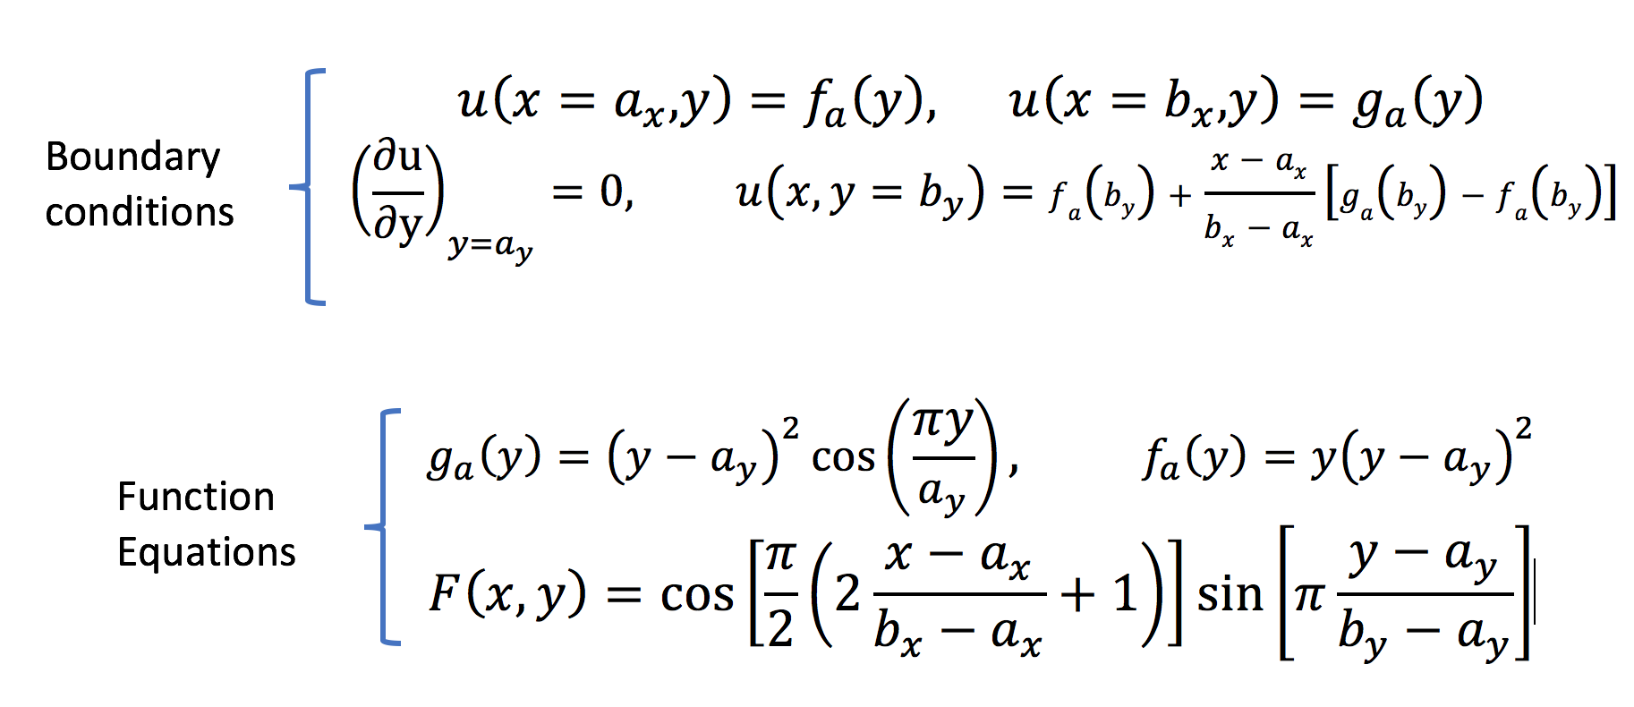

Figure 3- Boundary conditions (left, right, bottom and top respectively) and the equations used to calculate them

The equations from Figure 3 are all dependent of the x and y values in the n by m grid, n being the number of inner nodes in the x direction and m being the nodes in the y direction. The vector function F represents the values at every point in the grid, located on right hand side of Equation 1. This will be even more useful for the discretization part of the Helmholtz equation. The complexity of the problem comes from the only Neumann boundary condition, which is approximated by discretization.

Discretized version of equations:

In order to make the Helmholtz equation suitable for numerical evaluation it is important to begin by discretizing the Equation 1 from Figure 1. There are some steps to be taken to correctly discretize the equation and make it practical for approximation in MatLab, by using the iterative methods discussed previously. Figure 4 shows the steps taken to discretize the Helmholtz equation correctly.